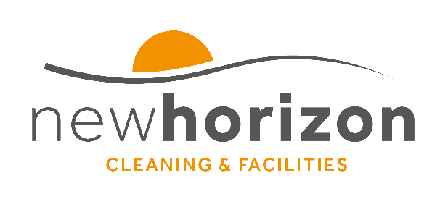
1.3 QUALITY, ENVIRONMENTAL and OH&S POLICY

It is the policy of New Horizon to maintain a quality system designed to meet the requirements of ISO9001:2015 & ISO14001:2015 & ISO45001:2018 in pursuit of our primary objectives, the purpose and the context of the organisation.

It is the policy of New Horizon to:

- strive to satisfy the requirements of all of our customers, stakeholders and interested parties whenever possible, meeting and exceeding their expectations.
- comply with all compliance obligations, codes of practice and all other requirements applicable to our activities including the nature, scale and environmental impacts of its activities, products and services;
- protect the environment, including prevention of pollution, sustainable resource use, climate change mitigation and adaptation, the protection of biodiversity and ecosystems and any other specific commitments which are relevant to the context of the organisation;
- ensure commitment to provide safe and healthy working conditions for the prevention of work-related injury and ill health which satisfies the requirements of all of our customers, stakeholders and interested parties whenever possible and is specific to our OH&S risks and OH&S opportunities.
- reduce hazards, OH&S risks, prevention of injury and ill health;
- provide all the resources of equipment, trained and competent staff and any other requirements to enable these objectives to be met;
- ensure that all employees are made aware of their individual obligations in respect of this policy, and ensure that consultation and participation of workers, to be actively involved in the management of the system and the activities supplied;
- provide all the resources of equipment, trained and competent staff and any other requirements to enable these objectives to be met;
- maintain a management system that will achieve these objectives and seek continual improvement in the effectiveness and performance of our management system based on “risk”.

This quality& environmental and OH&S policy provides a framework for setting, monitoring, reviewing and achieving our objectives, programmes and targets.

Customer satisfaction forms an essential part of our objectives and to ensure this is fulfilled, all employees receive training to ensure awareness and understanding of quality, H&S and environment tissues and their impact on customer service and of the products or service in which we provide.

To ensure the company maintains its awareness for continuous improvement, the management system is regularly reviewed by “Senior Management” to ensure it remains appropriate and suitable to our business and is subject to both internal and external annual audits.

Mark Bonnette
Director

